Data Extract – Reference Document
Execute Privilege
Overview:
The Data Extract Application is used to pull data out of Oracle Clinical and prepare it for reporting in either THERADEX or CDUS formats. The application allows for the creation, maintenance and execution of Study specific objects, views and cursors based upon a template structure.

URL:
https://octrials.nci.nih.gov/opa40/data_extract.htm

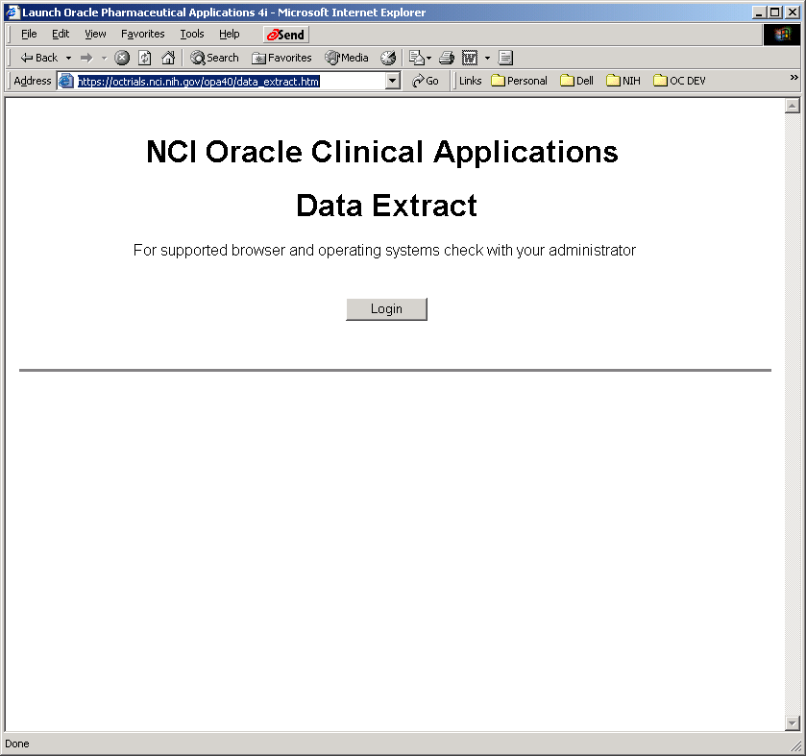

Pressing the “Login” button will allow the user the login to the Data Extract Application.
Figure 1 - Data Extract Screen
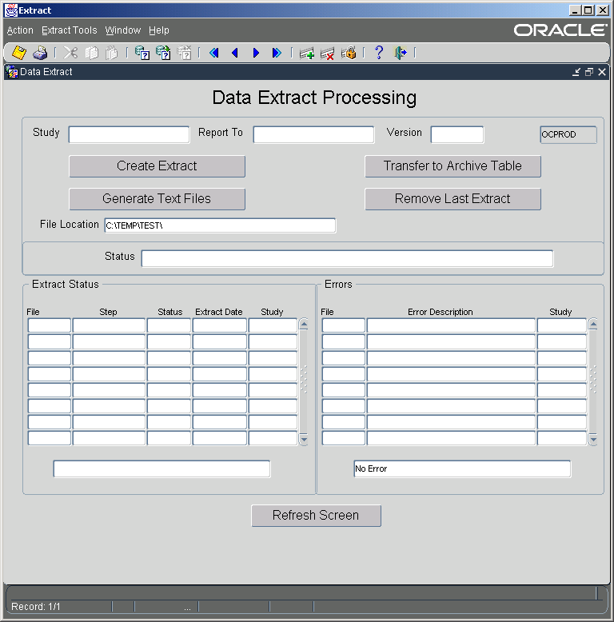

Primary Entry Fields:

Study | Study to perform extract on. This field has an LOV containing only those studies that have been set up for data extraction.
Report To | Represents the type of reporting being requested (THERADEX or CDUS). This field also has an LOV. This field is tied to the Version field as well, and will be filled via the LOV
File Location | This is the destination directory used when the “Generated Text Files” button is pressed. The destination directory is located on the application server.
NOTES: | Currently, network mapped drives attached to the application server are NOT being written to correctly.

Other Fields:

Database | This field displays the name of the database the application is connected to. It should always display OCPROD.
Status | Displays the current processing status. (Success, Failure)

Extract Status Block:

This block is used to display the current, or most recent processing status. Using the “Refresh Screen” refreshes this block. If the Study field contains data, then only those status that relate to the study will be displayed.
File | Represents the File Type Extracted
Step | Represents the step within the Extract for that particular file type.
Status | Current status
Extract Date | Date of Extraction.
Study | Study
Messages | The bottom field within the Extract Status Block is used to display informational messages during processing.
NOTES: | Double clicking on the Step, Status, or Study field will cause a more detailed screen of the entire record to be displayed.

Errors Block:

This block is similar to the Extract Status Block. It is used to display the relevant error messages related to the current, or most recent processing status. Using the “Refresh Screen” refreshes this block. If the Study field contains data, then only those status that relate to the study will be displayed.
File | Represents the File Type Extracted
Error Description | Contains the Step and Procedure at which the file extraction resulted in an unexpected error.
Study | Study
Messages | The bottom field within the Extract Status Block is used to display informational messages during processing.
NOTES: | Double clicking on the Error Description or Study field will cause a more detailed screen of the entire record to be displayed.

Buttons:

The normal processing of an extract is to first extract the data. Once extracted, the data is available via the Candidate Submission workbook in Oracle Discoverer. Once the extract is generated, the data can be moved to the archive area. Once the data is moved to the archive area the data can be viewed from Oracle Discoverer. If the data is extracted without errors, then the text files can be generated. If an error is found after the move to archive, the archive should be removed and the process should start over.
Create Extract | This button with use the Study, Report To and Version fields to create a data extract. This is a batch process. Once the button is clicked, the Refresh Button should be used to refresh the Status field and the Extract and Error Blocks. The LAST file type to execute is ‘ALL’.
Generate Text Files | This button is used to create a flat file of the extracted data for the extract represented by the Study, Report To and Version fields. The File Location field contains the destination of the output files.
Transfer To Archive Table | This button is used to copy the Extracted Data from the temporary extract tables, to the archive tables.
Remove Last Extract | Removes the most recently extracted data set from the archive tables, using the Study, Report To and Version fields.
NOTES: | Double clicking on the Error Description or Study field will cause a more detailed screen of the entire record to be displayed.

Figure 2 - Refresh Extract Views
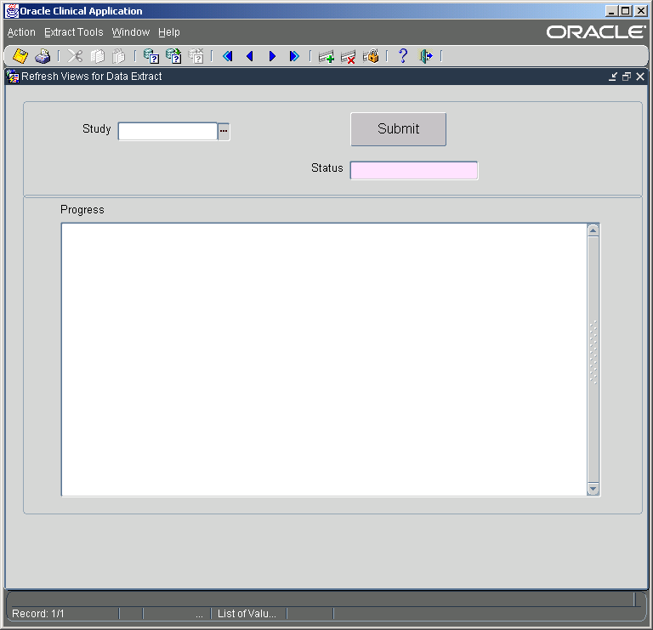

Summary:
This form is used to recompile all of the extract views for a particular study. The process queries the view definitions stored in CT_EXT_VW_CTL and recreates those views.

Primary Entry Fields:

Study | Study to perform the refresh on. This field has an LOV containing only those studies that have been set up for data extraction.
Status | Displays final status after the procedure has completed.
Progress | Displays messages related to the processing of the refresh.
NOTES: | This form is access via the “Extract Tools” pull down menu by the “Refresh Extract Views” option.

Buttons:

Submit | This button is used the start the Refresh process. Study must be entered prior to using this button.

Figure 3 - Extract Tools Pull Down Menu
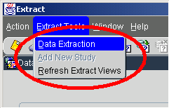

Menu Access:

Each form in the Data Extract application has the same application menu. The “Action” menu contains the normal Oracle Forms menu commands in a single pull down menu. The “Extract Tools” pull down contains options for accessing additional functionality of the Data Extract application. Users with “Execute” privileges with have access to the “Extract Tools” pull down menu with the following available options:
Data Extraction | This is the primary form, used to perform the extract of study data.
Refresh Extract Views | This menu option is used to access the Refresh Extract Views form.
NOTES: | When moving between the different options of the application, a new window is opened for the newly accessed form, if that particular function is not already open.

